Storm Over Cheron

Paul M. Summitt

Paul M. Summitt
312 Proctor Drive
Columbia, MO 65202
573-554-8635
paulmsummitt@outlook.com
STORM OVER CHERON
Overview
Theme / Setting / Genre
Core Gameplay Mechanics Brief
Targeted platforms
Monetization model (Brief/Document)
Project Scope
Influences (Brief)
- <Influence #1>
- <Influence #2>
- <Influence #3>
- <Influence #4>
The elevator Pitch
Project Description (Brief):
Project Description (Detailed)
What sets this project apart?
Core Gameplay Mechanics (Detailed)
- <Core Gameplay Mechanic #1>
- <Core Gameplay Mechanic #2>
- <Core Gameplay Mechanic #3>
- <Core Gameplay Mechanic #4>
Story and Gameplay
Story (Brief)
Story (Detailed)
Gameplay (Brief)
Gameplay (Detailed)
Assets Needed
- 2D
- 3D
- Sound
- Code
- Animation
Schedule
- <Object #1>
- <Object #2>
- <Object #3>
- <Object #4>

Overview

High Concept Statement
STORM OF CHARON is a top-down 2D fantasy/adventure of the sword and sorcery genre that takes place in the world of Cheron. TheNext good Queen Celeste of Charon is being held captive at Table Rock Castle by the evil sorcerer/emperor Dominicon, who is currently ruling the world of Cheron.

Game Play
The first goal of the game is for the player/adventurer to recruit and increaase the size and strength of his or her army.
Second, the player/adventurer must find and collect the five crowns of Cheron that are hidden in the world of Cheron.
Finally, after the player/adventurer has collected all five crowns, he or she may attempt to attack and capture Table Rock Castle, the capital of Cheron, and rescue Queen Celeste. A large and powerful army is almost a requirement for this feat.

Targeted platforms
- Web
- Android
- Linux
- Windows

Monetization model
- Free. Open Source. This game is being built and designed as an experiment and learning experience for all those envolved. Donations of support are not requested but will be greatfully accepted.

Project Scope
- <Game Time Scale>
- Cost? My time and the time of those who wish to volunteer to assist with this project
- Time Scale: Unknown at this point in time

- <Team Size>
- <Core Team>
- Paul M. Summitt
- Retired
- Volunteer
- <Licenses / Hardware / Other Costs>
- Licenses
- Only open source software will be used in the development of this game
- Hardware
- Game will be designed and built on linux platforms
- Other Costs
- Unknown at this point in time
- <Total Costs with breakdown>

Influences (Brief)

- <Influence #1>
- Literature – The Gor and Conan series of science fiction/fantasy books.
- After Tarzan and Robinson Crusoe, these two series of books were a constant source of exploration for my teenage years.

- <Influence #2>
- Literature/Movies – The Hobbit and The Lord of the Rings.
- I began reading these books during the late 1960s and continued throughout the 1970s. I reread them again during the 1980s and 1990s while preparing to watch the various movie series. I have seen every movie based on the books and will probably reread the books again as I prepare for the possible upcoming television series.

- <Influence #3>
- - Game – Dungeons and Dragons
- - While I’ve only had the opportunity to play this game a few times, I have many of the instruction books as well as online and computer tools that enhance the play of this game.

- <Influence #4>
        - - Game – Quest for the Key of Nightshade, originally written in BASIC for either a Model I or Model III TRS80 computer by David Schmidt and published in the February 1983 issue of 80 Micro magazine.
        - - This was one of, if not the first, computer game I ever typed into a computer, debugged, and then played. The experience taught me quite a bit about BASIC programming.

The Elevator Pitch
Storm over Cheron is a single player, sword and sorcery adventure game allowing players to fight against beasts, magical entities, monsters, and armies of the dead in their quest to free the true leader of Cheron, Queen Celeste.

Project Description (Brief)

Project Description (Detailed)

<Four Paragraphs or more If needs be>
<No more than six paragraphs>

What sets this project apart?
- <Reason #1>
- <Reason #2>
- <Reason #3>
- <Reason #4>
- <etc.>

Core Gameplay Mechanics (Detailed)

- <Core Gameplay Mechanic #1>
- <Details>
/Describe in 2 Paragraphs or less/
- <How it works>
/Describe in 2 Paragraphs or less/

- <Core Gameplay Mechanic #2>
- <Details>
/Describe in 2 Paragraphs or less/
- <How it works>
/Describe in 2 Paragraphs or less/

- <Core Gameplay Mechanic #3>
- <Details>
/Describe in 2 Paragraphs or less/
- <How it works>
/Describe in 2 Paragraphs or less/

- <Core Gameplay Mechanic #4>
- <Details>
/Describe in 2 Paragraphs or less/
- <How it works>
/Describe in 2 Paragraphs or less/

Story and Gameplay

Story (Brief)

<The Summary or TL;DR version of below>

Story (Detailed)

The planet-wide peace of Charon has been shattered. Monsters walk this once peaceful world. The good Queen Celeste has been taken captive by the evil sorcerer Dominicon and he has set himself up as emperor. He enforces his will on the people of Cheron through his army of Demon Warriors. These Demon Warriors, and their enslaved dragons, also guard Queen Celeste at Dominicon’s fortress, Table Rock Castle.
The player/adventurer starts off alone on their journey around the planet in search of gold, weapons, armor, and companions. It is the player/adventurer’s goal to raise a powerful army, find the five crowns of Cheron, and to attack Table Rock Castle, and to free Queen Celeste. During this journey, the player/adventurer will meet and deal with other humans, wild animals, magical beasts, dragons, gremlins, and demons.

Gameplay (Brief)
<The Summary version of below>

Gameplay (Detailed)
<Go into as much detail as needs be>
<Spare no detail>
<Combine this with the game mechanics section above>

Assets Needed

- 2D
- Display – The screen is divided into seven sections: header, left, upper right, lower right, middle, bottom status, and footer. The header section is the uppermost section seen and displays the name of the game, version number, and copyright information. The left section displays the player’s status such as type of armor, health, skill level, weaponry, and number of spells acquired and unused. The upper right section displays the movement options available to the player and allows for the entry of game commands. The lower right section displays a smaller version of the map showing the entire world with the sections of the planet discovered by the player revealed. The middle and largest section of the display is the graphic map displaying the immediate area and terrain around the player’s center position. The bottom status section is a communication area displaying warnings and other such necessary information as needed. The footer section displays game status data such as total treasure accumulated and number of crowns collected.
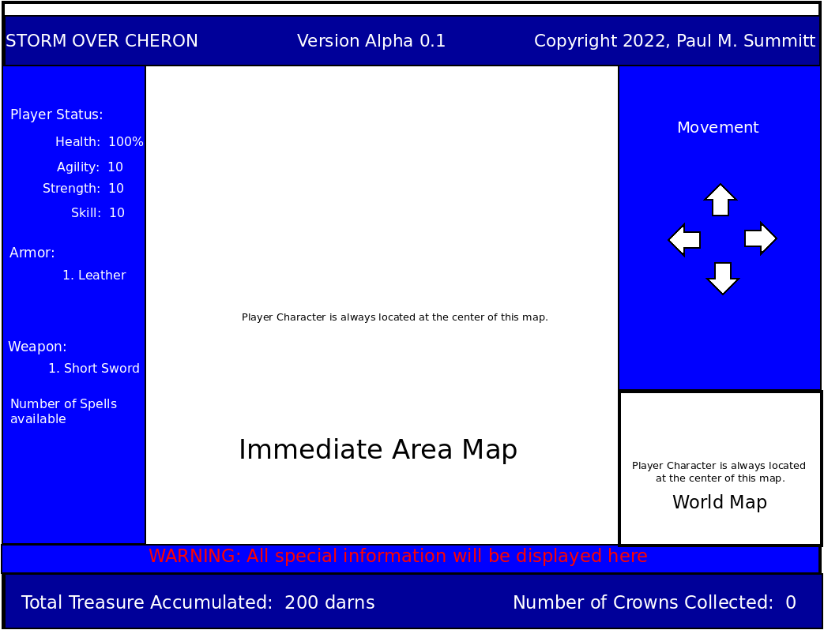
- Environment Textures
- Required data
- The playing field of Cheron as seen in the World Map section is 500 x 500 units in size. Each unit is on possible location where a player’s character may be located. If a player moves continually to the West (left), or to the North (up), South (down), or East (right), they will leave that edge of the map and enter on the opposite edge of the map. The center display shows the terrain for three units in any direction from the player’s position. As the player moves in any direction, the player remains stationary and the terrain moves beneath the player’s location. Landmarks such as rivers, lakes, mountain, caves, swamps, and deserts remain in the same location during each playing of the game. Man-made objects, such as castles, towns, villages, graveyards, tombs, and tunnels will vary in location from one game instance to another.

- Character List
- Player Character - The Player character is always centered in the map. The arrow keys are used to move the player character North (up arrow key), South (down arrow key), East (right arrow key), or West (left arrow key) one hex at a time.
- Queen Celeste -
- Dominicon -
- Humans -
- Nasai – Nasai are female warriors from the desert tribe of the Sai. These females are human and are armed with a large hunting bow and a small sword. The Nasai wears a cloak and has little or no armor. Her Fighting Ability is 5 with the sword and 6 with the bow. Nasai are known to individually approach a man seductively and then attack him with her sword when the player lets their guard down. Nomadic by nature, Nasai travel either singly or in bands of up to twelve. They live by piracy and are extremely dangerous but can be negotiated with. Each Nasai carries a backpack filled with the treasures of those they have robbed and killed.
- Creature List
- Demon Warrior – Demon Warriors are highly trained soldiers. Each wears partial plate armor and a helmet and is armed with a spiked shield and a broadsword. Each warrior has tremendous strength, speed, and agility giveng them the Fighting Ability of 15. Pain has little effect on them. The must be killed as they never negotiate and never surrender. Demon Warriors are always found in packs of four. They are most often found guarding castles or towns. At least one pack of four is found in a castle, sometimes more. Demon Warriors carry no treasure, but if killed, their weapons and armor may be taken by the player.
- Fire Dragon – With a wingspan of over twenty-five meters (eighty-two feet) and standing over fifteen meters (forty-nine feet) in height, the Fire Dragon has large claws and fangs and breathes fire. The Fire Dragon is chained to the walls of Table Rock and is guarding Queen Celeste. The Fighting Ability of the Fire Dragon is determined randomly in each instance of the game, by the skill level chosen by the player. A fight with the Fire Dragon is always a fight to the death. Luckily, there is only one Fire Dragon.
- Minor Dragons – The size of a minor dragon varies depending on their age. The largest minor dragon can have a wingspan of fifteen to eighteen meters (forty-nine to fifty- nine feet) while standing nine to 12 meters (twenty-nine to thirty-nine feet). Minor Dragons make tunnels and caves their lairs and are always found in mountainous terrain. The Fighting Ability of a minor dragon depends on its age and the skill level chosen by the player. Minor dragons can not breath fire and most often, again depending on their age, have a small to medium cache of treasure. If left alone, minor dragons rarely attack, but will defend their lair. Minor dragons are most often found alone but can sometimes be found as a mated pair.
- Krithsock – The Krithsock is up to 3 metres ( just less than ten feet) tall and looks like a cross between a terran Iguana and an ostrich. The Krithsock has a long neck, short front legs, and a small head that is mostly beak. With very large webbed rear feet and a long, powerful tail (which is used both for balance and propulsion, the Krithsock travels extremely fast in the water but is rather slow on dry land. These creatures are found only in water areas and have a Fighting Ability of 4. The Krithsock is a herbivore and scabenger. Basically a timid creature, the Krithsock spends its day wading marshy areas in search of grass and the occasional dead carcass. Krithsock blood is considered an antidote for some poisons.
- Byzon – Ten meters ( thirty-two feet) in length, the Byzon is a greenish-brown, venemous reptile with large fangs that can pierce most types of armor. The head is guarded with large bone protrusions. Quick and agile with a Fighting Ability of 7, the Byzon is capable of striking with its tail while luging with bared fangs. The Byzon is also fond of coiling around its prey and constricting, smothering the life out of its hapless victim. The Byzon is primarily found in open areas at night and in caves or tunnels during the day. It can be known to hang in trees. The Byzon is edible and considered a delicacy by many on Cheron.
- Manfish – Found in water areas, the manfish is an amphibious humanoid covered in scales. It has gills, a large fin down its back, rows of dangerous sharp teeth, and long sharp claws. The Manfish can breath both in and out of water and sometimes of 11. Manfish live in small, partially submerged cities. Thier primary source of food is fresh water clams, crayfish, and fish. They will attack and kill humans that get too close to their cities. Manfish carry small amounts of treasure, found or stolen from their victims, on their person. The manfish are not very intelligent.
- Gargon – The Gargon looks like a Terran Hammerhead shark with legs. Found only in water areas and living in underwater caves, the Gargon is about four meters (thirteen feet) long with rough, thick, scaly, sand-paper like skin. The Gargon has two rows of large, sharp, saw-edged teeth in extremely powerful jaws. It has a Fighting Ability of 8. The Gargon’s fins have bones in them and the Gargon can walk for short distances from the water for hunting or to sun itself. Gargon are edible.
- Mancat – Mancats are one and a half meters (about five feet) tall. They are intelligent, feline humanoids. Found only in mountainous terrain, mancats are extremely social creatures. While they arm themselves with short swords, they are not particularly good with them. Extremely strong, the mancat will usually, if forced to fight, attempt to disarm their opponent and overpower them. Mancats prefer to run if possible when confronted. The mancat has a Fighting Ability of 5. Overall, these creatures are a stealthy and thieving species. The mancat carries small amounts of treasure on their person.
- Satan Crab – Found only in the desert, the Satan Crab is about two feet) tall. Lacking intelligence, the Satan Crab acts purely on instinct. Strong, but slow, the Satan Crab has a large horn protruding from its head and long claws at the ends of its arms. It has a Fighting Ability of 8 and will fight anything and everything it encounters. On sighting something, the Satan Crab will immediatly attack and, upon killing it, devour whatever it kills. It has a voracious hunger and eats anything.
- Pigmy Dragons – Pigmy Dragons are vicious, one meter ( a little over three feet) long, sand lizards, found only in the desert. They have a long, poisonous spike at the end of their tail, small blunt teeth, and sharp claws. They have a Fighting Ability of 6. Their stunted wings are useless. Their skin is thick and scaly. Their teeth are useless as weapons but the poison in their tail will kill a man within five minutes unless an antidote of Krithsock blood is not consumed by the victim. Pigmy Dragons are stealthy and many times use suprise to great advantage. Their coloration blends in perfectly with their desert surroundings and they spend most of the day lying motionless to avoid exertion in the heat. At night, they hunt rodent-like creatures called daggits. Pigmy dragons are occasionally domesticated and raised for their meat which is highly edible.
- Cangor – Cangors can grow to four meters (a little over thirteen feet) in length. A terran panther-like animal, Cangors are found near graveyards and in caves, tunnels, or tombs. They have sleek black fur, large white teeth, and glowing red eyes. Few humans have survived a Cangor attack. They have a Fighting Ability of 12.
- Hellcat – A two meter (six and a half foot) bear-like creature, the Hellcat’s body is covered with an outer shell of thick, hardened calcium. Two large tusks protrude from its lower jaw and the creature has a long tail with a mace-like ball at the end. The Hellcat has the ability to teleport itself from location to location and is able to sneak up on its opponents as a result. The Hellcat is found primarily in caves, tunnels, and tombs, but can be found short distances from these locations because of their ability to teleport. They have poor eyesight but excellent hearing and are attracted to shiney objects. Their primary prey are daggits. They have a Fighting Ability of 10.
- Daggit – A small, no more than a quarter of a meter (eight tenths of a foot) in length, edible, terran rabbit-like creature. Daggets have no Fighting Ability, running being their only defence. Daggets are prey animals.
- Apeman – A meter (three and a quarter feet) tall humanoid creature, the apeman’s body is covered in long, black hair while its head is covered with long, white hair. Short and squat, the apeman is remarkably strong for its size. Found primarily in northern and southern mountainous areas, it is nocturnal and sleeps by day in caves, tunnels, or tombs. It hunts by night, daggets being their primary prey. With a mouth filled with razor-like teeth, and long claws at the end of their arms, the apeman carries a small knife which it likes to quickly plunge into its victim. The Apeman has a Fighting Ability of 6. Capable of moving silently with great speed, it can remain motionless for up to three hours at a time. While expert in ambush, the apeman can’t fight very well when caught in the open.
- Wolfmount – Standing two meters (about six and a half feet) at the shoulder, the wolfmount is generally black in color and heavyset. Being carnivorous, wolfmounts have extremely sharp teeth. Males have a horn centered on their forehead much like the terran mythical unicorn. Most wolfmounts are wild but some have been domesticated and, though dangerous, can be ridden. Wolfmounts fight with their teeth and claws and the males can use their horn in battle. They have also been known to trample prey. They have a Fighting Ability of 7. Wild wolfmounts travel in packs and their primary prey are human and humanoid creatures. Wild wolfmounts are primarily found in mountainous terrain.
- Sabertooth Nighthunter – A five meter long terran tiger-like creature, the Nighthunter has large fangs, powerful jaws and sharp claws. Found only in mountainous terrain living far from human settlements, the Nighthunter is one of the most dangerous carnivores on Cheron. With a Fighting Ability of 14, the Nighthunter has great speed and agility. Its fur is so thick on most of its body that many swords can’t penetrate it. Nighthunters, both male and female, are extremely protective of their cubs. Their main prey are Wolfmounts and other large forest-dwelling creatures. The flesh of the Nighthunter is edible and is often used for medicinal purposes.

- Sound4
- Sound List (Ambient)1
- Outside
- Level 1
- Level 2
- Level 3
- etc.
- Inside
- Level 1
- Level 2
- Level 3
- etc.

- Sound List (Player)
- Character Movement Sound List
- Example 1
- Example 2
- etc.
- Character Hit / Collision Sound list
- Example 1
- Example 2
- etc.
- Character on Injured / Death sound list
- Example 1
- Example 2
- etc.

- Code
- Human Class pseudo-code
public class humans
{
public human()
{
public String humanName;
private int strength = 0;
private int speed = 0;
private int agility = 0;
private int treasure = 0;
public String humanType;
private String locationType;
public Coordinate position;
private Array armorType;
private Array weaponType;
}

public static void main(String[] args)
{
human player = new human();
human Soldier = new human();
human Merc = new human();
human Nasai = new human();
human Sorcerer = new human();
human Blacksmith = new human();
human Townspeople = new human();
}
}

- Creature Class pseudo-code
public class creatures
{
public creature()
{
int strength = 0;
int speed = 0;
int agility = 0;
int treasure = 0;
String creatureName;
String creatureType;
String locationType;
Coordinate position;
Array armorType;
Array weaponType;
}

public static void main(String[] args)
{
creature demonWarrior = new creature();
creature fireDragon = new creature();
creature minorDragon = new creature();
creature pigmyDragon = new creature();
creature krithsock = new creature();
creature byzon = new creature();
creature manFish = new creature();
creature gargon = new creature();
creature manCat = new creature();
creature satanCrab = new creature();
creature cangor = new creature();
creature hellcat = new creature();
creature daggit = new creature();
creature apeMan = new creature();
creature wolfmount = new creature();
creature sabertoothNighthunter =new creature();
}
}

- Method names
      - getPosition(coordinate)
      - setPosition(coordinate)
      - move(Direction)

- Animation
- Environment Animations
- Example
- etc.
- Character Animations
- Player
- Example
- etc.
- NPC
- Example
- etc.

Schedule

- <Object #1>
- Time Scale
- Milestone 1
- Milestone 2
- Etc.

- <Object #2>
- Time Scale
- Milestone 1
- Milestone 2
- Etc.

- <Object #3>
- Time Scale
- Milestone 1
- Milestone 2
- Etc.

- <Object #4>
- Time Scale
- Milestone 1
- Milestone 2
- Etc.

